Chapter 3 p.55

Most targeted sectors

Pie chart showing percentages of the most targeted sectors. It shows A. Government: 27%, B. Think tanks/NGOs: 21%, C. Education: 11%, D. IT: 9%, E. Intergovernmental organizations: 9%, F. Défense Industry: 6%, G. Energy: 3%, H. Health: 2%, and I. Other: 10%.

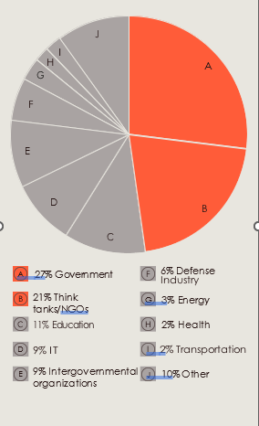

Source: Microsoft Threat Intelligence nation state notifications